**WorkForage**

Based on your project documents (All_Project_Reports_With_Details and WorkForage_Project_Report), here’s a complete breakdown of the **WorkForage** project — tailored for both **business owners (clients)** and **freelancers**, including:

* All modules
* Navbar content
* Front-end/back-end technology stack

**🧩 Complete Modules – WorkForage**

**👤 Client (Business Owner) Modules**

1. **User Authentication**
   * Register/Login with role = client
   * Session management
2. **Post a Task / Problem**
   * Title, description, budget, deadline
   * Edit/delete posts
   * Task status: open/closed/assigned
3. **View & Manage Proposals**
   * See proposals for posted tasks
   * View freelancer profile from proposal
   * Accept/reject proposals
4. **Chat with Freelancer**
   * After selecting freelancer
   * Real-time or pseudo real-time chat (AJAX)
5. **Review & Feedback**
   * Submit review after task completion
   * Rating stored for freelancer
6. **Client Dashboard**
   * View posted problems and their status
   * Messages, notifications, reviews

**🧑‍💻 Freelancer Modules**

1. **User Authentication**
   * Register/Login with role = freelancer
   * Session management
2. **Freelancer Profile**
   * Add/edit skills, description, profile picture
   * Display average rating, completed tasks
3. **Browse & Filter Tasks**
   * View all open tasks
   * Filter by budget, deadline, skill keywords
4. **Submit Proposal**
   * Bid amount, cover message
   * Track proposal status
5. **Chat with Client**
   * Real-time or pseudo real-time chat
6. **Review & Rating**
   * Give review to client after task completion
7. **Freelancer Dashboard**
   * View applied tasks, messages, ratings

**🗃️ Database Tables**

* users – info, role (client/freelancer), ratings
* problems – tasks posted by clients
* proposals – freelancer applications
* messages – chat logs
* ratings – feedback entries
* admin – admin credentials

**🧭 Navbar Content**

**For Clients (Business Owners)**

| **Section** | **Icon (Optional)** | **Description** |
| --- | --- | --- |
| Dashboard | 📊 | Overview of posted tasks and messages |
| Post Problem | ➕ | Form to create a new task |
| Proposals | 📥 | View applications from freelancers |
| Messages | 💬 | Chat area |
| Reviews | ⭐ | Reviews from and for freelancers |
| Profile | 👤 | Account info, logout |

**For Freelancers**

| **Section** | **Icon (Optional)** | **Description** |
| --- | --- | --- |
| Dashboard | 🧭 | View applied tasks and stats |
| Browse Problems | 🔍 | List of open tasks |
| Proposals Sent | 📤 | Track proposal statuses |
| Messages | 💬 | Chat with clients |
| My Profile | 👤 | Skills, rating, edit profile |
| Reviews | ⭐ | View feedback |

**🧑‍💻 Frontend Stack**

| **Technology** | **Purpose** |
| --- | --- |
| **HTML5** | Page structure |
| **CSS3** / Tailwind or Bootstrap | Styling |
| **JavaScript** | Front-end logic |
| **React.js** (optional) | Dynamic UI components |
| **AJAX/Fetch API** | Asynchronous messaging/chat |

**🛠️ Backend Options (Choose One)**

| **Technology** | **Use** |
| --- | --- |
| **PHP + MySQL** | Lightweight, fits your current doc |
| **Flask (Python)** | Easy setup for REST API + Python |
| **Node.js + Express** | Modern, scalable backend stack |

For real-time chat, Node.js + WebSockets would work best, but you can use **AJAX polling with PHP/Flask** for simpler implementation.

**🌐 Suggested Folder Structure**

/WorkForage

│

├── /client

│ ├── index.html

│ ├── dashboard.html

│ └── ...

│

├── /freelancer

│ ├── index.html

│ ├── browse.html

│ └── ...

│

├── /assets

│ ├── /css

│ ├── /js

│ └── /img

│

└── /database

└── schema.sql

**Landing Page: Before Login/Signup:**



(Remove the navbar from this image and in these cards give the about us type detail for the user. It is basically a landing page.)

**Login/Signup Page:**

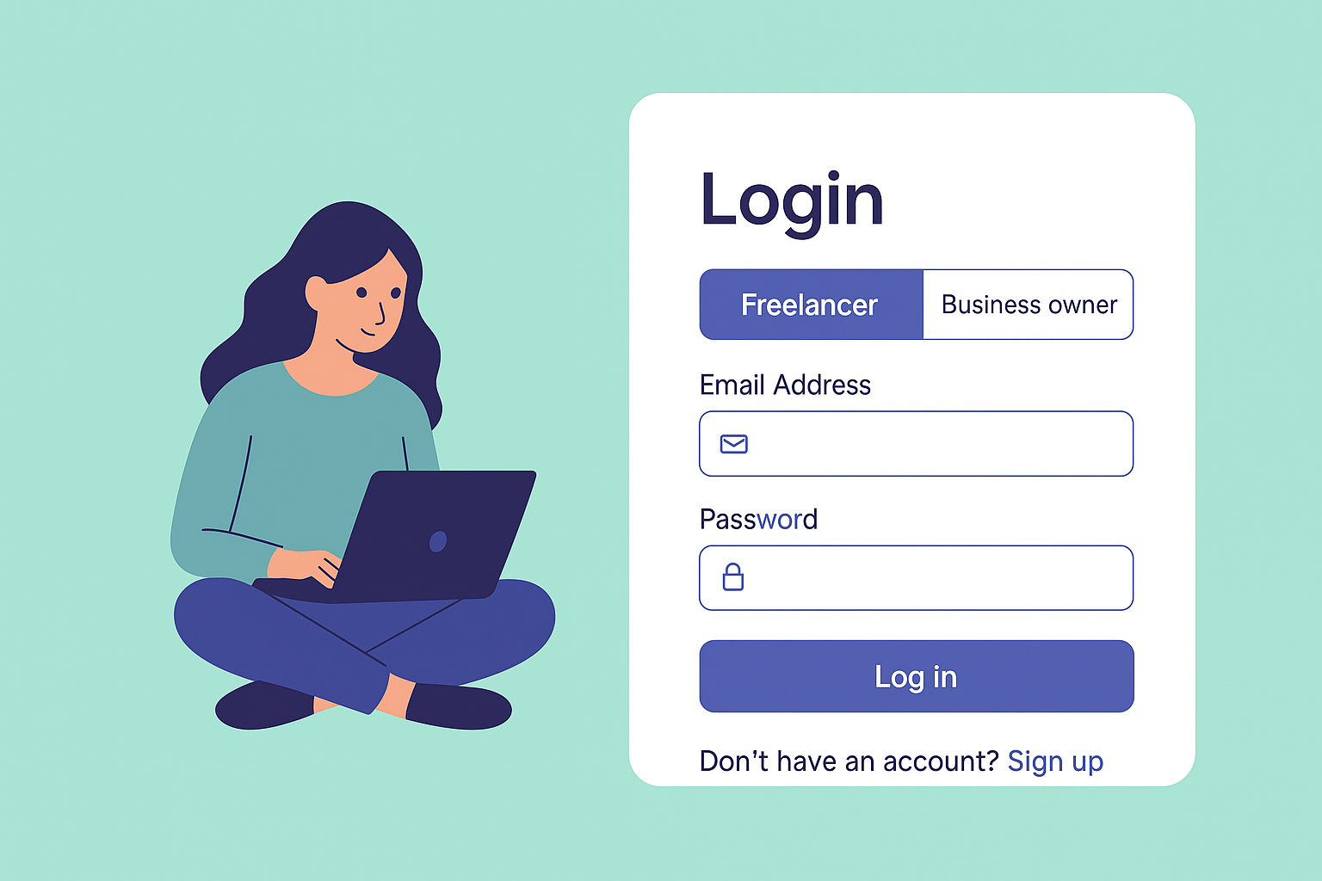

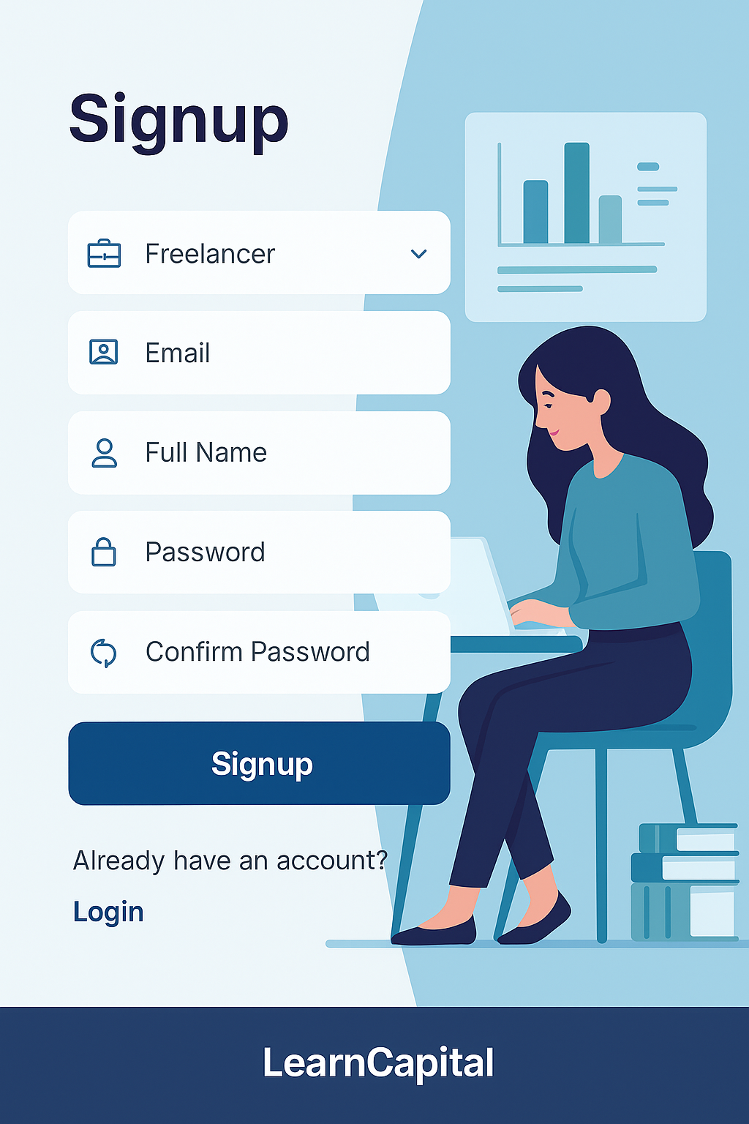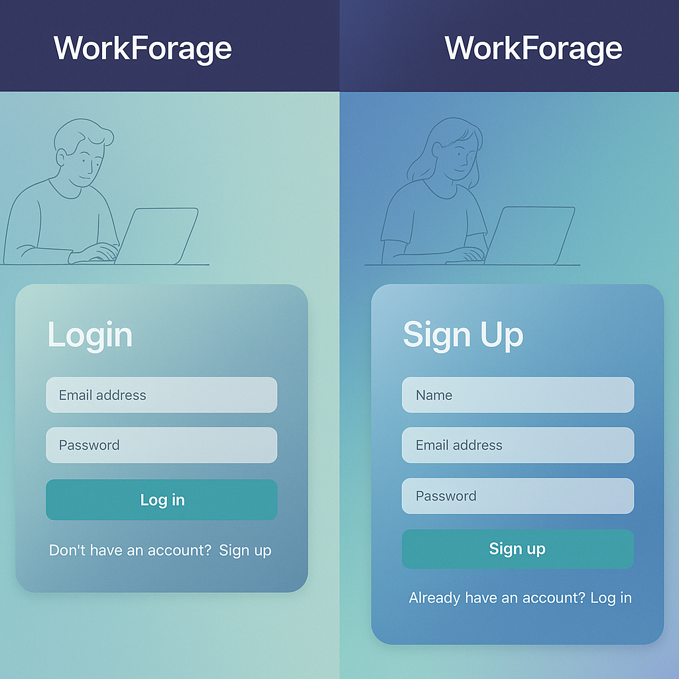

(Here we have to make the login and signup similar to above login and signup(separately) with the color theme of this login/singup(combine))

**Freelancer Side:**

**Dashboard:**

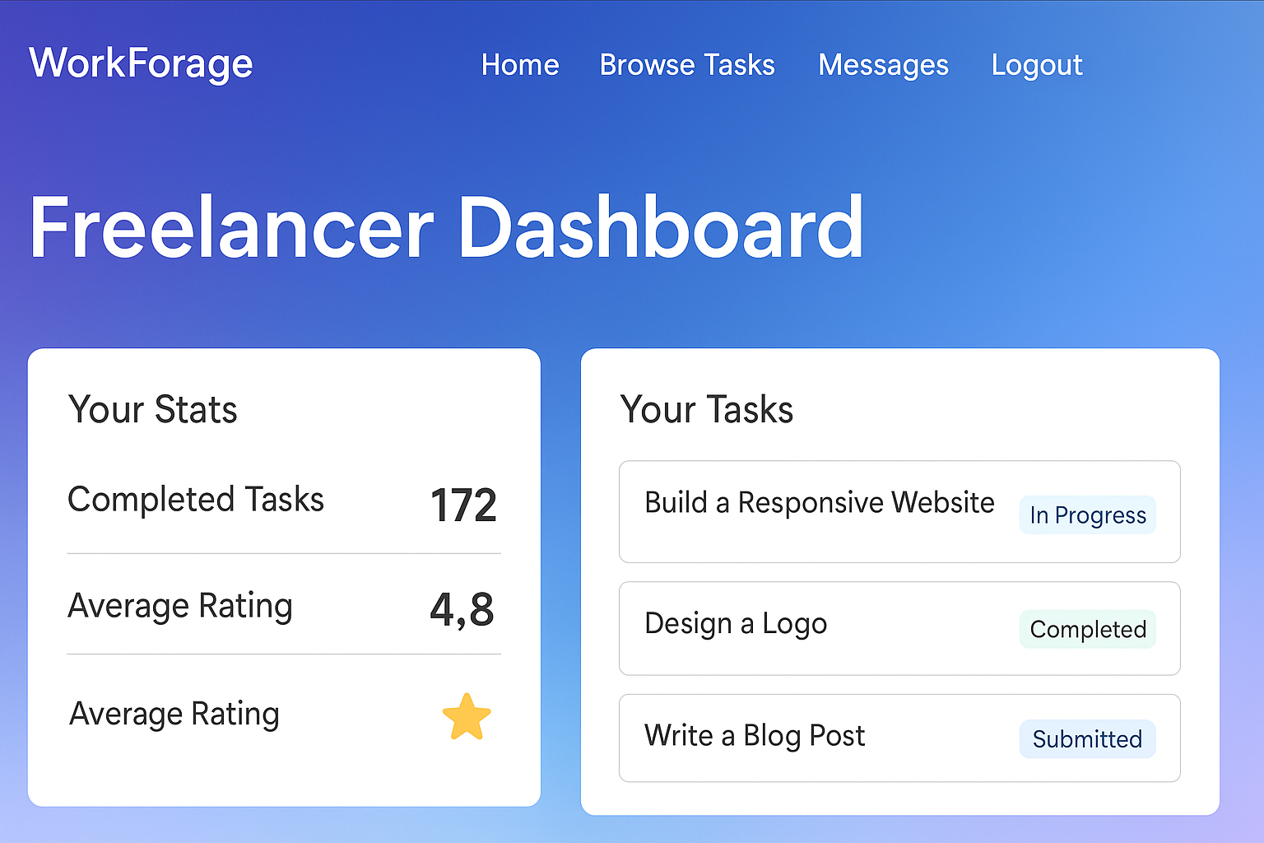

(Watch the alignment and contents)

**Freelancer Profile:  
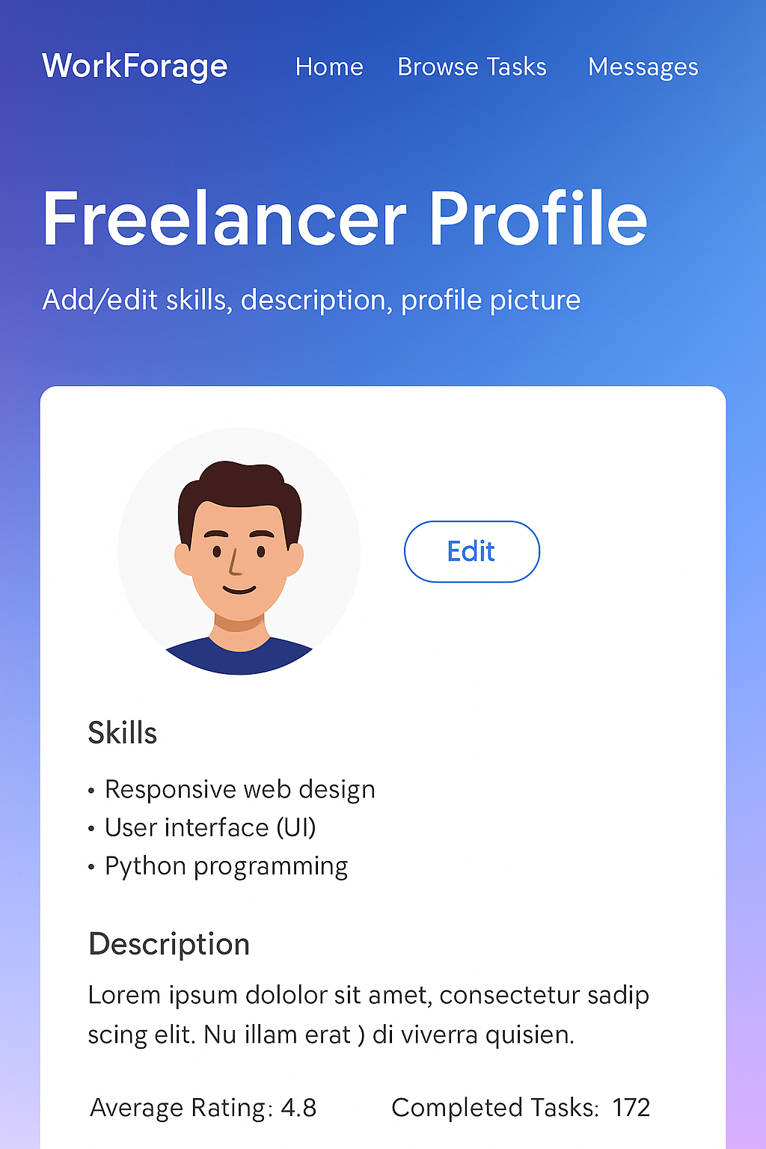**

(Make the alignment of this page according to the need of our project and make a the alignment for this better)

**Browse & Filter Tasks:**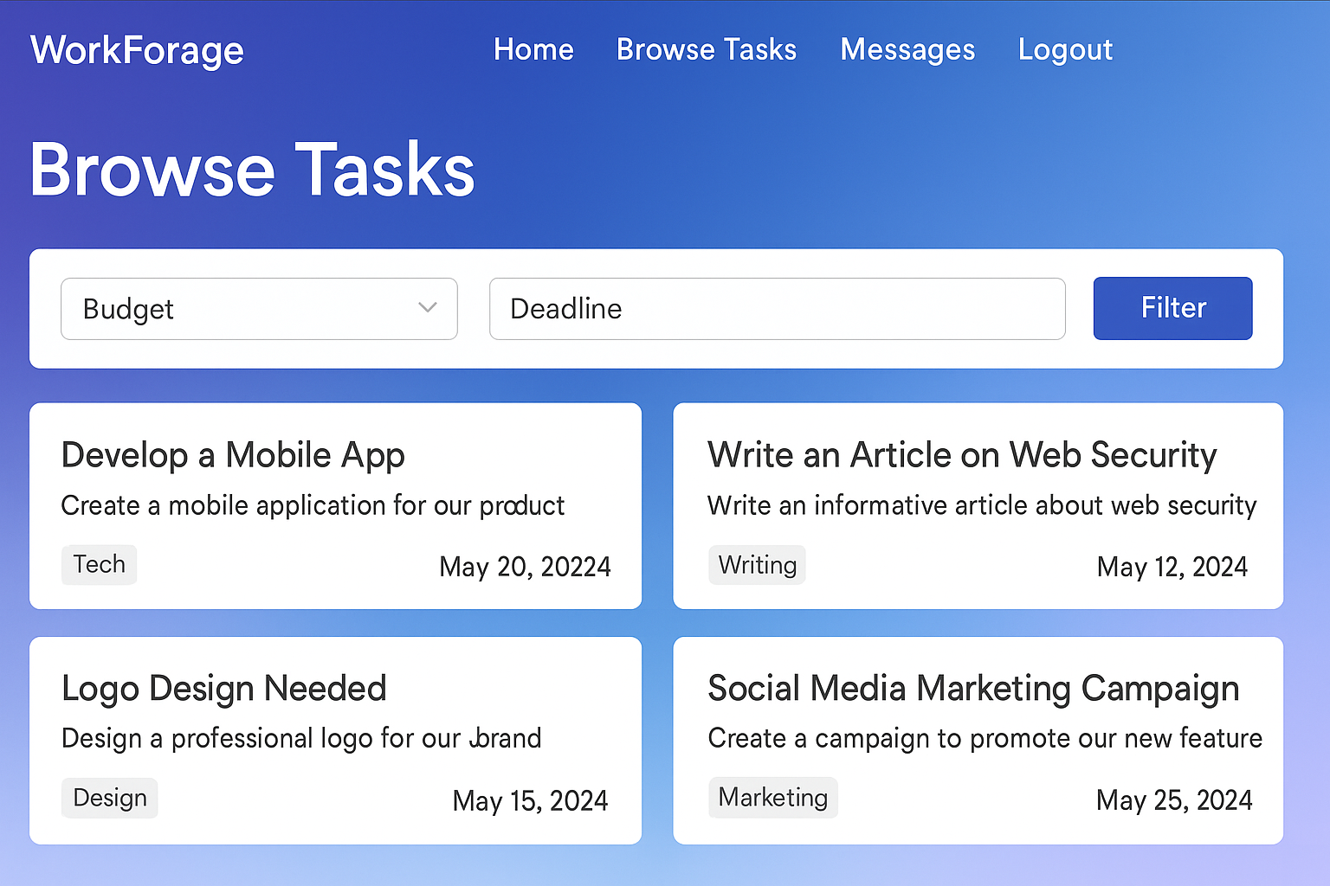

(Add proper images and icons)

**Submit Proposal:**

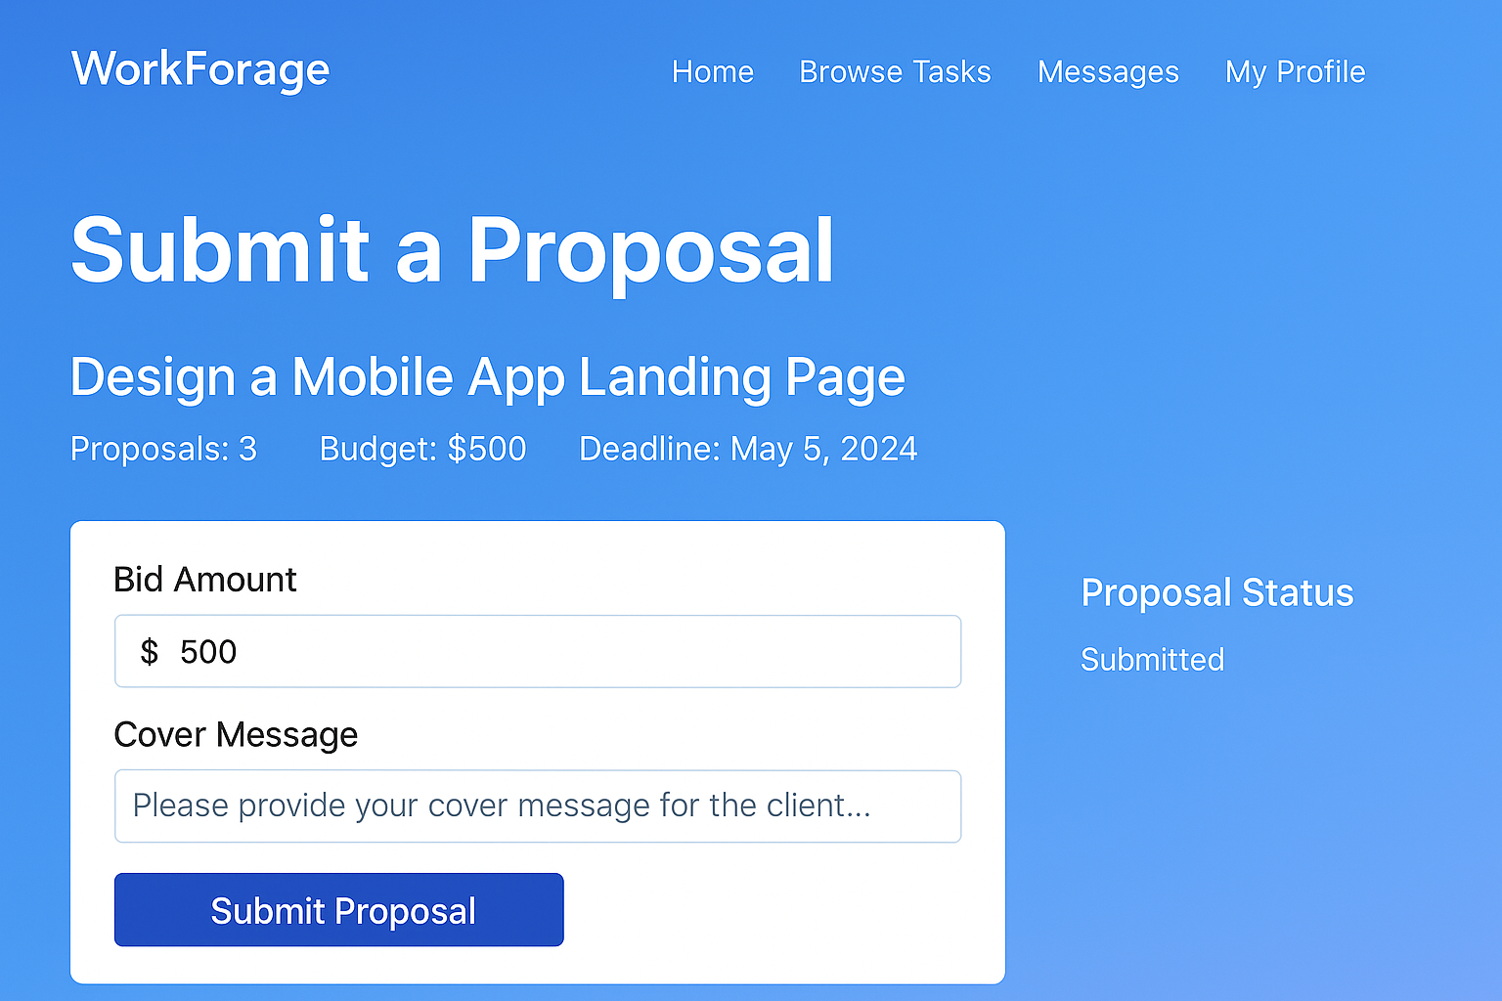

(Keep the background as others)

**Chat with Client:**

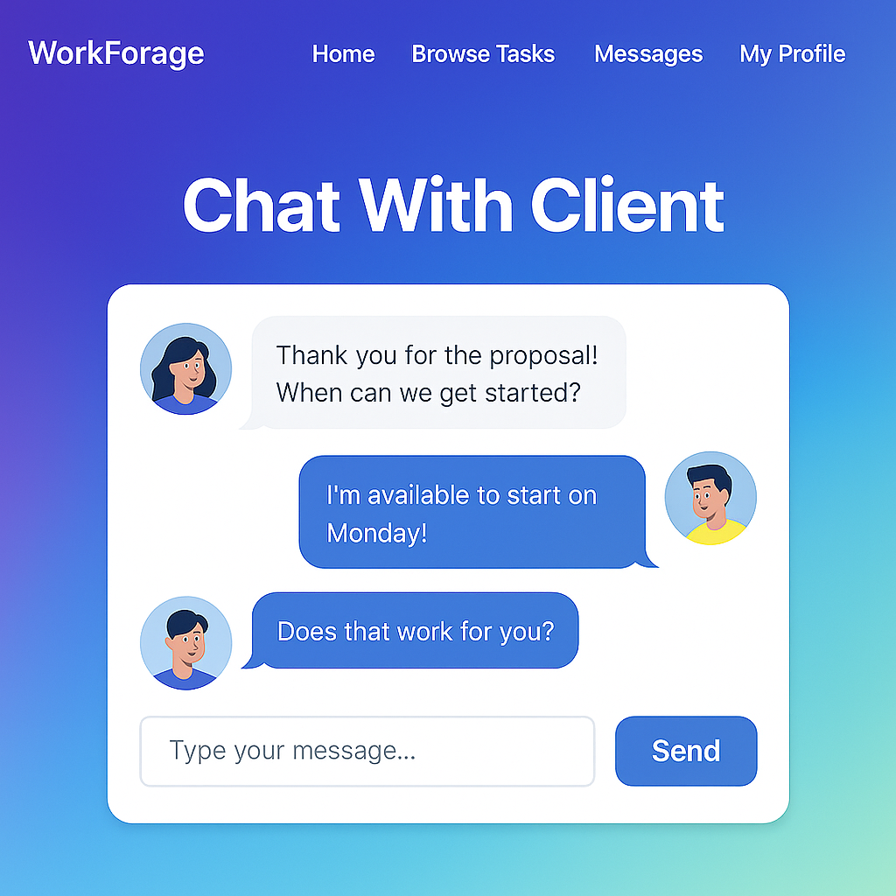

**Review & Rating:**

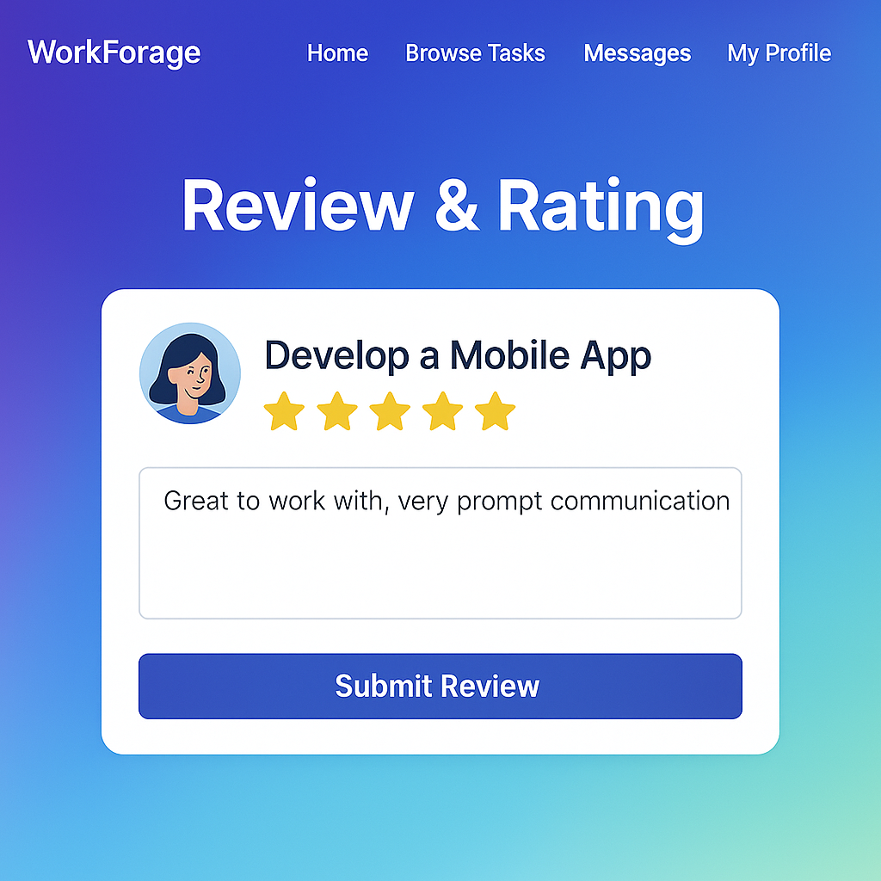

**Client Side:**

**Dashboard:**

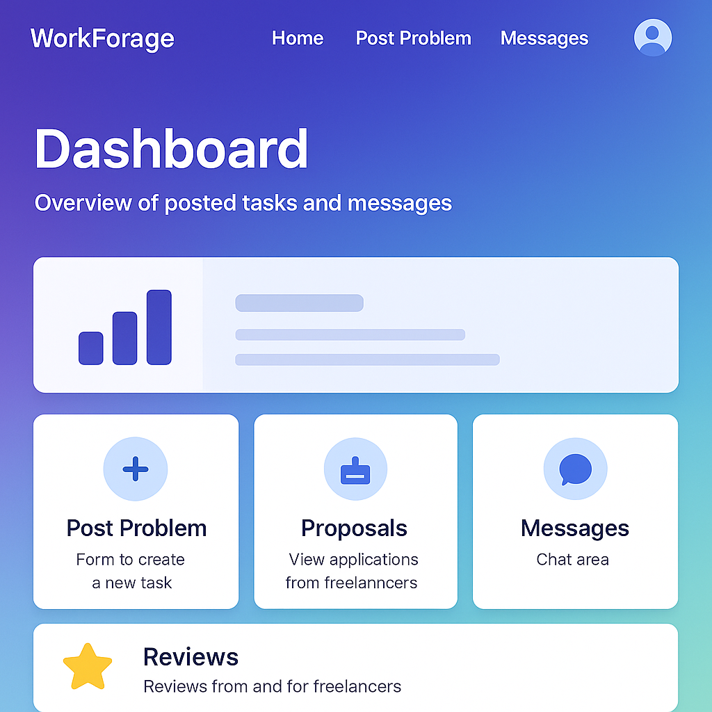

**Post-Problem:**

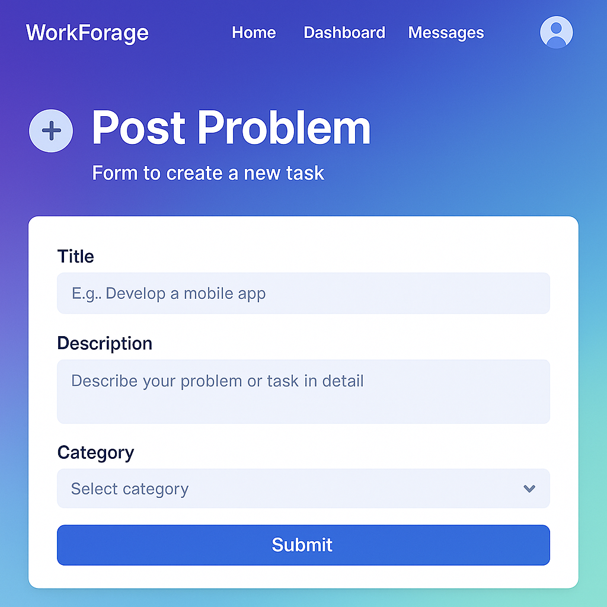

**Proposal:**

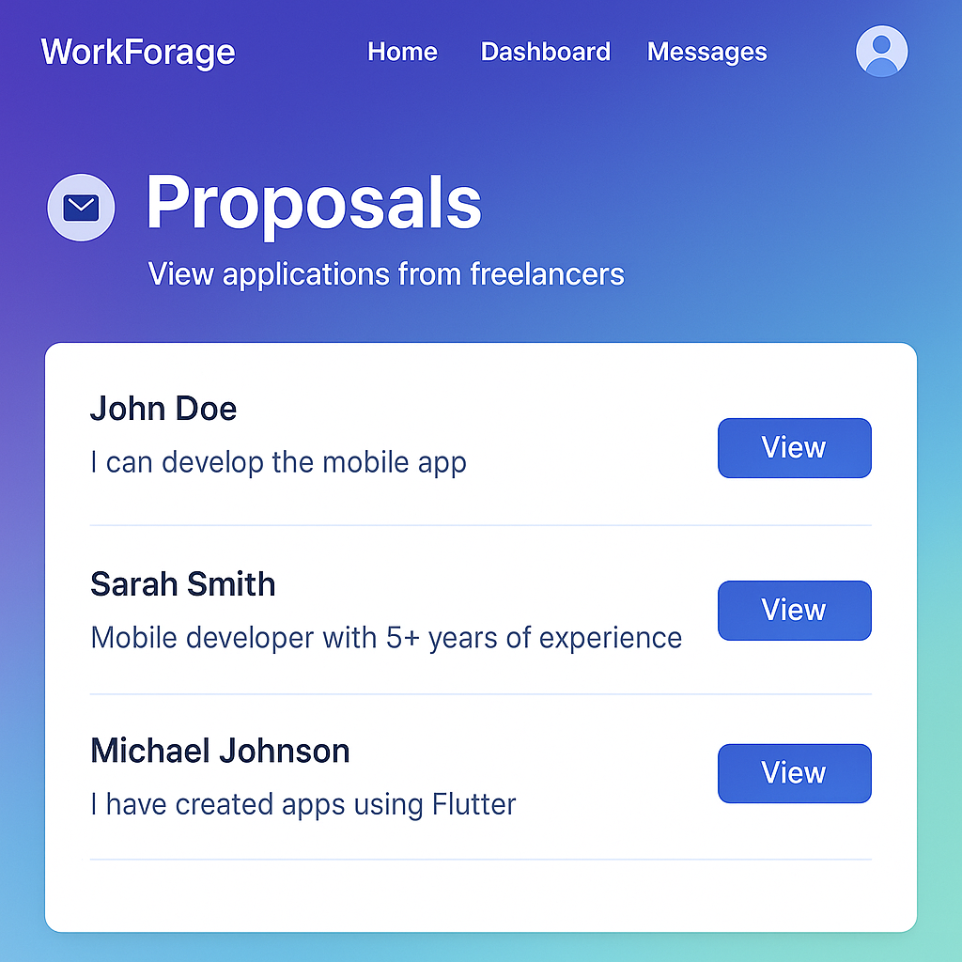

**Messages:**

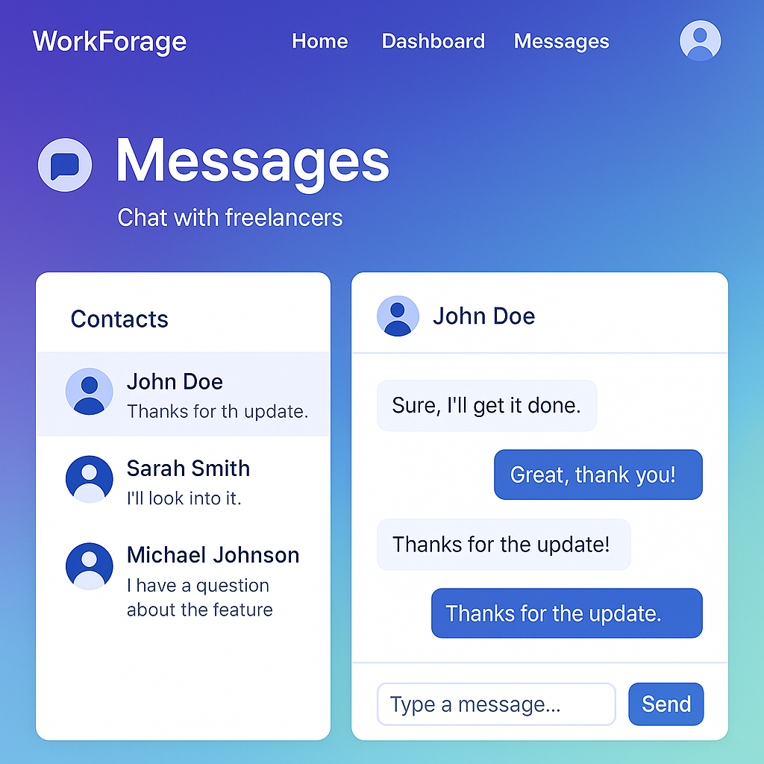

**Profile:**

